WHITEWATER EXPRESS CAR WASH
Electrical Safety Program
Revised Date: December 2025
Version 1.3
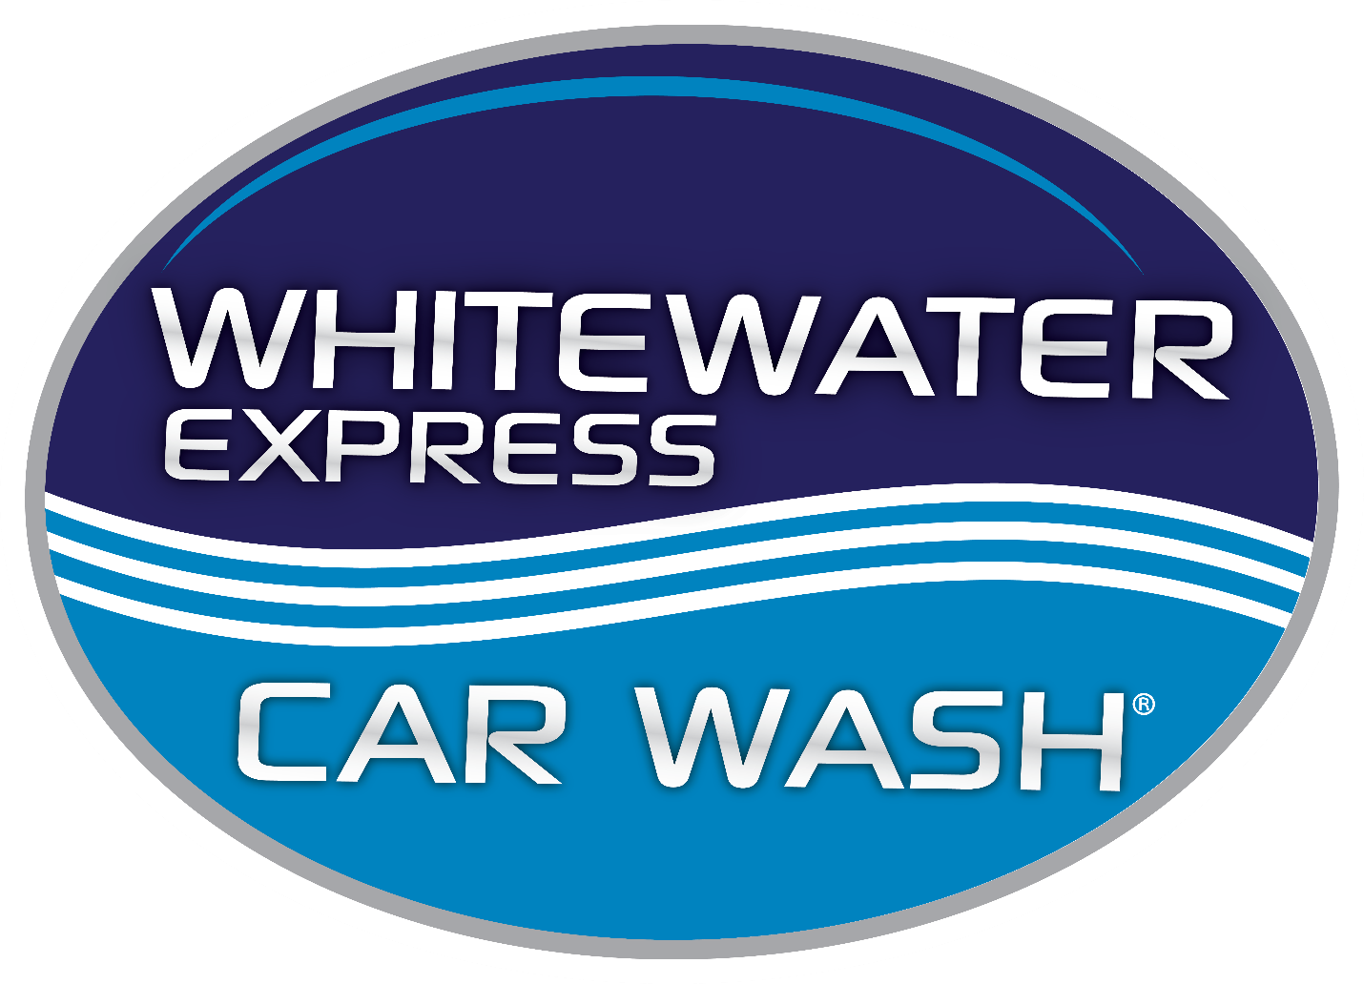

TABLE OF CONTENTS

- Purpose & Scope
- Definitions
- Roles & Responsibilities
- General Electrical Safety Requirements
4.1 Guarding of Live Parts
4.2 Electrical Equipment in Wet Areas
- Ground-Fault Protection (GFCI Requirements)
- Lockout/Tagout (LOTO)
- Inspection & Preventive Maintenance Program
- Personal Protective Equipment (PPE)
- Training Requirements
- Emergency Response Procedures
- Recordkeeping Requirements
- Continuous Improvement

1. Purpose & Scope
The WhiteWater Express Car Wash Electrical Safety Program establishes the procedures, responsibilities, and minimum standards necessary to prevent injuries from electrical hazards. This program incorporates OSHA 29 CFR 1910 Subpart S (Electrical), OSHA 1910.147 (LOTO), NFPA 70/70E principles, and industry best practices applicable to car wash environments.
This program applies to all Whitewater employees, contractors, temporary workers, and visitors who work near, around, or with electrical systems and equipment.

2. Definitions
Qualified Person: A worker with documented training, demonstrated skills, and authorization to work on or near exposed energized electrical parts.
Unqualified Person: An employee who may operate equipment but is not permitted to perform electrical repair or access energized parts.
Authorized Person: An employee who has completed required Lockout/Tagout (LOTO) training and is approved to apply locks/tags.
Energized Work: Any work performed on equipment that has not been de-energized, locked out, and verified.
GFCI (Ground-Fault Circuit Interrupter): A device that interrupts electricity when a ground fault is detected.
LOTO: A safety procedure used to control hazardous energy during maintenance or repair. (Full LOTO program referenced separately.)
Wet Location: Any area where moisture, spray, or standing water is present, including wash bays, tunnels, and vacuum/exterior areas.

3. Roles & Responsibilities
Management
- Ensure all electrical systems meet applicable codes and standards.
- Provide resources, PPE, training, and support for compliance.
- Ensure all required inspections, documentation, and LOTO procedures are maintained and reviews annually.
- Approved qualified and authorized employees.
Supervisors
- Enforce electrical safety rules in daily operations.
- Maintain training logs, GFCI logs, inspection records, and any corrective actions.
- Immediately address hazardous conditions and escalate as needed.
Employees
- Follow electrical safety rules in daily operations.
- Report damaged cords, outlets, motors, or hazards immediately.
- Never bypass GFCI’s, safety guards, or protective devices.
- Participate in required training and refreshers.

4. General Electrical Safety Requirements
- All electrical installations must meet local, state, and federal codes.
- Maintain a minimum 36-inch clearance in front of electrical panels.
- All panel directories must be accurate, legible, and updated when changes occur.
- Electrical room and MCC (Motor Control Center) doors must remain closed and properly labeled.
- Only fiberglass ladders may be used around electrical components.
- Remove conductive jewelry or clothing when working near electrical parts.
- Ensure adequate lighting near electrical equipment.
- Qualified personnel only may open energized MCC cabinets.
- Unqualified personnel must follow LOTO procedures and verify zero energy before accessing internal components.

4.1 Guarding of Live Parts
- Live electrical parts must never be exposed unless necessary for testing or repair by qualified personnel.
- All junction boxes, panels, control cabinets, and enclosures must have intact covers.

4.2 Electrical Equipment in Wet Areas
- Only NEMA 3R, 4, or 4X enclosures are permitted in wash bays and tunnels.
- All conduits in wet locations must be sealed and corrosion resistant.
- Damaged enclosures or seals must be reported and replaced immediately.

5. Ground-Fault Protection (GFCI Requirements)
To reduce shock hazards in wet environments:
- All 120-V outlets in wet or damp areas must be GFCI-protected.
- Monthly GFCI testing is required and must be documented.
- Portable electrical equipment must never be used without GFCI protection.
- GFCI pigtails must be used where permanent GFCI outlets are not available.
Recordkeeping Requirements:
- GFCI pigtails must be used where permanent GFCI outlets are not available.

6. Lockout/Tagout (LOTO)
Whitewater Car Wash maintains a separate, written LOTO Program that includes machine-specific procedures for:
- Conveyor motors
- High-pressure pumps
- Blowers and dryers
- Hydraulic equipment
- Electric doors
- Control stations
LOTO steps (require every time)
- Shutdown
- Isolation
- Lock & Tag
- Verification
- Maintenance/service
- Safe restart
Additional requirements:
- Only authorized employees may perform LOTO
- LOTO procedures must be reviewed annually.
- Retraining is required after job changes, policy changes, or observed deficiencies.
Records retention:
- Annual LOTO audits and logs must be kept for at least one year.

7. Inspection & Preventive Maintenance Program
Daily (Operators)
- Inspect cords, plugs, motors, control stations, and equipment for visible damage.
- Ensure electrical panels remain closed.
- Remove standing water from around electrical equipment.
Monthly (Supervisor/Safety) – Documented
- Test and document all GFCIs.
- Inspect motors, disconnect, and control panels for wear or damage.
- Verify accurate panel labeling.
- Check seals, gaskets, and conduit in wet locations.
- Confirm extension cords, adapters, and pigtails are in good condition.
Annual (Qualified Electrician or Certified Inspector)
- Perform thermal imaging on electrical panels.
- Inspect grounding and bonding
- Review all panel directories
- Evaluate aging equipment and recommend upgrades.
Inspection log retention: minimum of three years.

8. Personal Protective Equipment (PPE)
- Dry, non-slip, electrically rated footwear required in wet or saturated areas.
- Qualified employees performing electrical troubleshooting must use insulated gloves, face shields, arc-rated clothing, and other NFPA 70E PPE.
- Employees may not perform energized work unless fully trained, qualified, and authorized.

9. Training Requirements
All Employees
- Electrical hazards recognition
- Safe use of extension cords and equipment
- GFCI testing
- Basic emergency response
- Awareness-level LOTO information
Authorized/LOTO Personnel
- Full LOTO training
- Annual refresher or retraining when conditions or job duties change
Qualified Electrical Personnel
(Typically, a third-party contractor unless designated by management)
- NFPA 70E arc-flash concepts
- Troubleshooting/testing skills
- System-specific design and operational understanding
Training records retention: duration of employment + 3 years.

10. Emergency Response Procedures
- Ensure the area is safe and disconnect power if possible.
- Never touch a person who is being shocked.
- Call emergency services immediately.
- Secure the scene and avoid moving equipment unless necessary for rescue.
- Once safe, take thorough photos (close-up and distance).
- Notify management.
- Complete incident documentation.
- Equipment must be inspected and repaired before returning to service.

11. Recordkeeping Requirements
Whitewater will maintain records for:
- Training (retention: employment + 3 years)
- GFCI testing logs (3 years)
- Monthly/annual inspections (3 years minimum)
- LOTO audits and logs (1 year minimum)
- Maintenance, repairs, and corrective actions.

12. Continuous Improvement
Whitewater Car Wash is committed to:
- Reviewing this program annually or after incidents, inspections, or noted deficiencies
- Incorporating new technologies that improve safety
- Encouraging employee feedback
- Striving to exceed minimum OSHA requirements where feasible

